Questionnaires – Loneliness

**Basic Demographic Questions**

1. **Age**: What is your age?
2. **Gender**: What is your gender?
   * Male
   * Female
   * Non-binary/Other
   * Prefer not to say
3. **Education**: What is the highest level of education you have completed?
   * No formal education
   * High school or equivalent
   * Vocational training/Some college
   * Bachelor’s degree or higher
4. **How would you describe your main racial/ethnic background?**

* Australian – neither Aboriginal nor Torres Strait Islander
* Australian Aboriginal or Torres Strait Islander
* Pacific Islander, or other Oceania
* British or European
* Asian
* Middle Eastern
* African
* North American
* Central or Southern American
* Other

1. **Primary Language**: What is your primary language?

Theory of Mind Inventory (TOMI)

Interpersonal Reactivity Index (IRI)

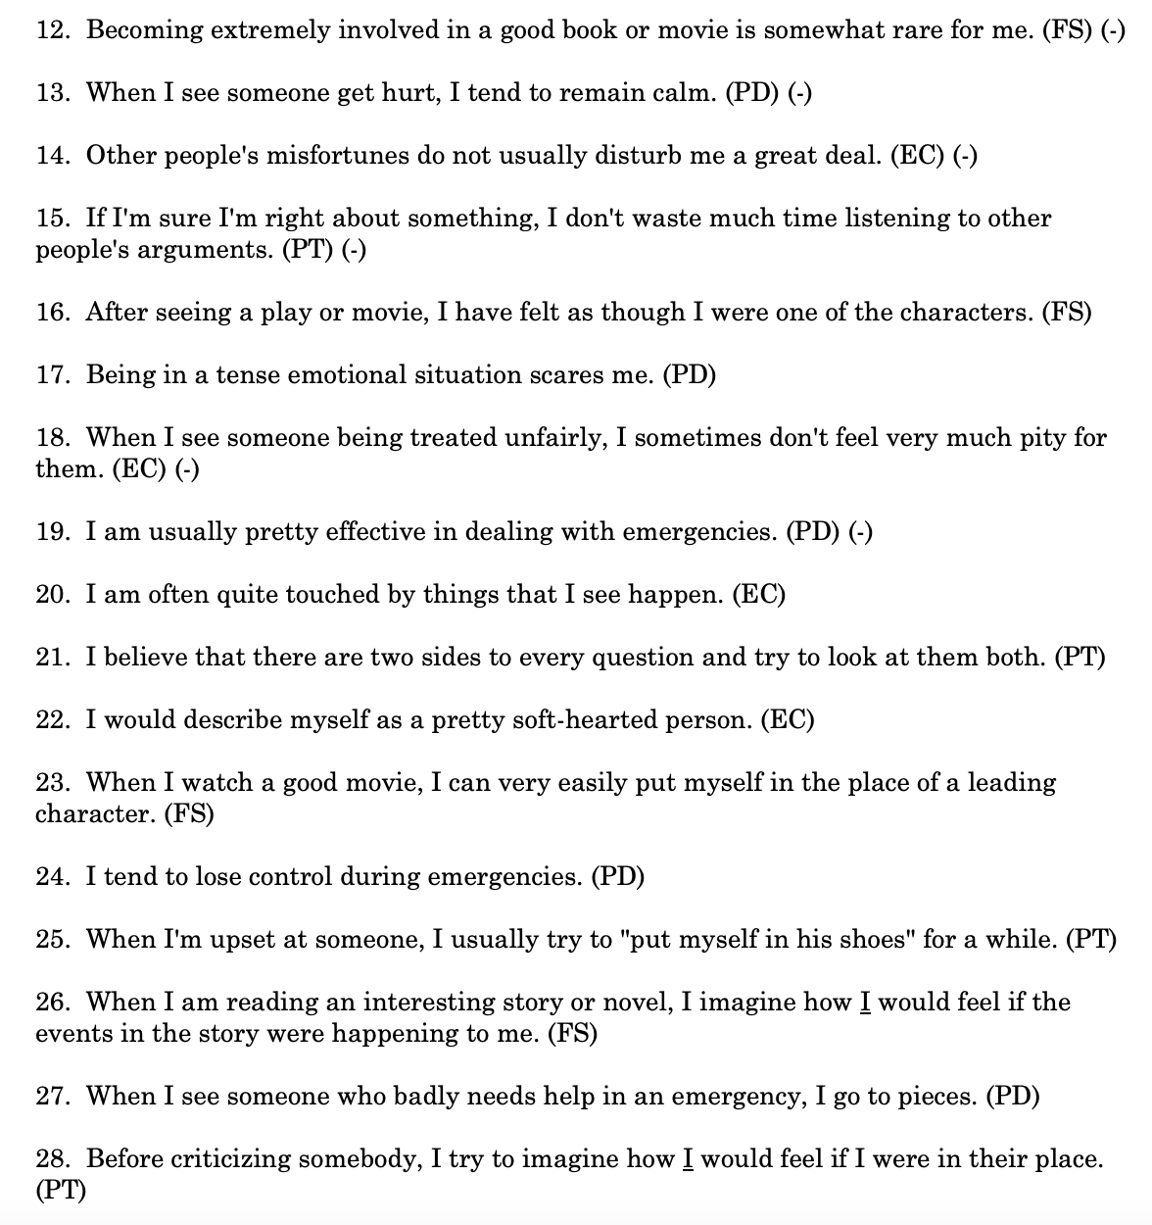

**Social & Emotional Loneliness Scale for Adults – Short Version (SELSA-S DiTommaso et al., 2004)**

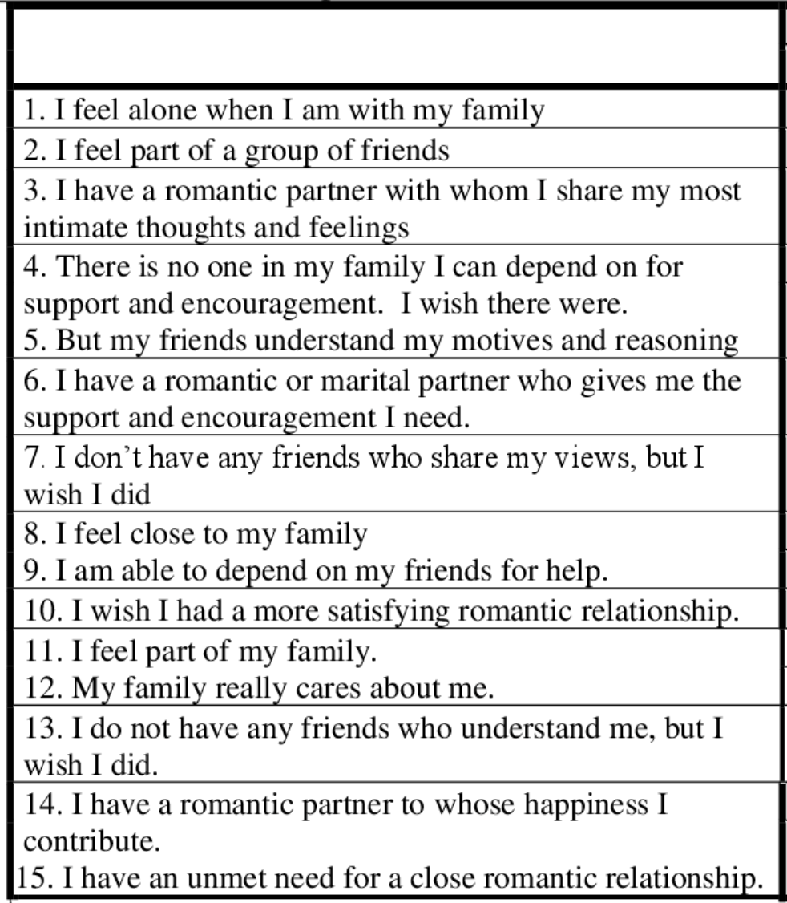

**Brief scale of existential loneliness** (McKenna- Plumley et al., 2024)

DASS 21

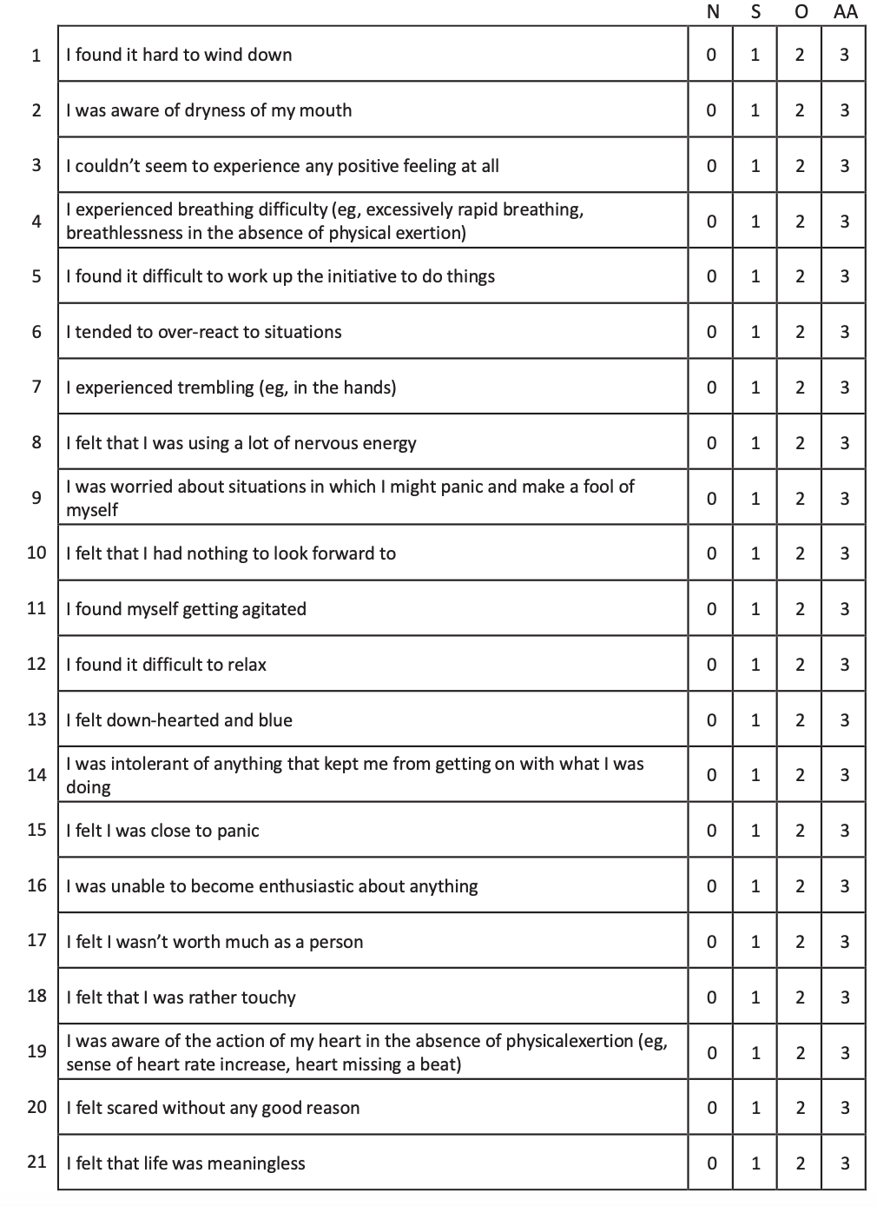

**Experiences in Close Relationships – Revised (ECR-R; Fraley, Waller & Brennan 2000)**

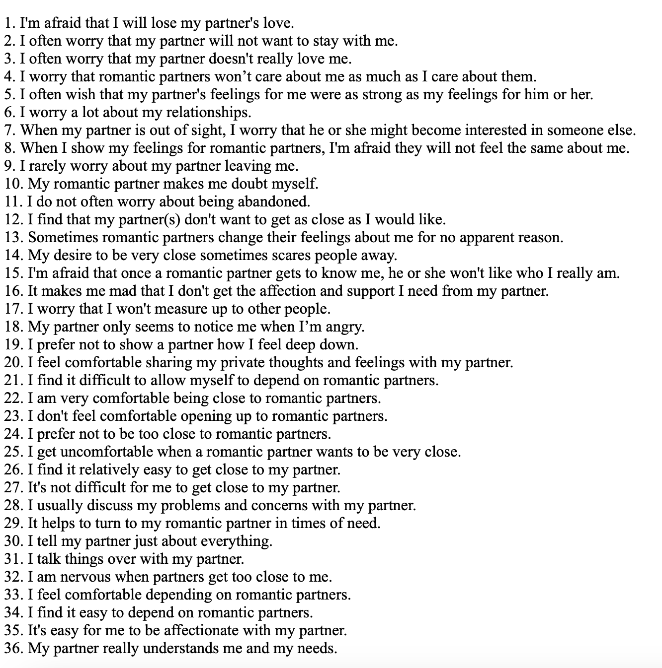

**UCLA Loneliness Scale**

**Meaning in Life Questionnaire (MLQ; Steger, et al., 2006)**

**Student Adjustment to College Questionnaire (SACQ)**

**Prosociality Scale (Caprara et al., 2005)**

**Multidimensional Scale of Perceived Social Support (MSPSS; Zimet et al. 1988)**

**Difficulties in Emotion Regulation scale (DERS; Gratz & Roemer 2004)**

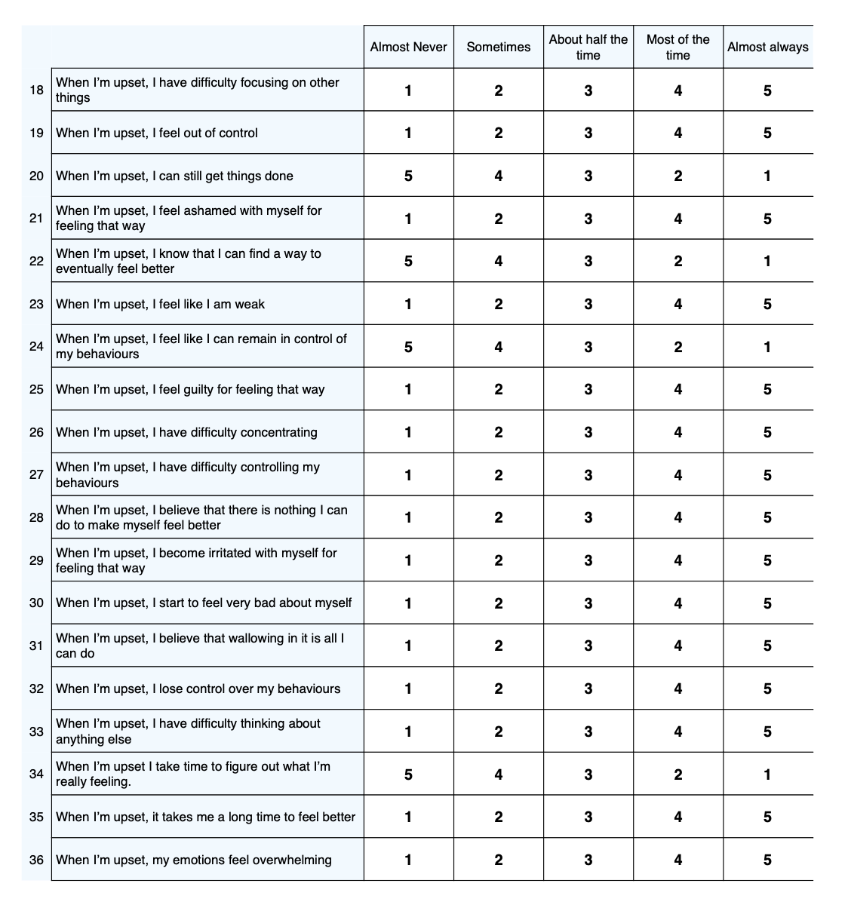

**EmpaTOM task:**

Resources including stimuli to be utilised available here: <https://osf.io/gfa3t/>

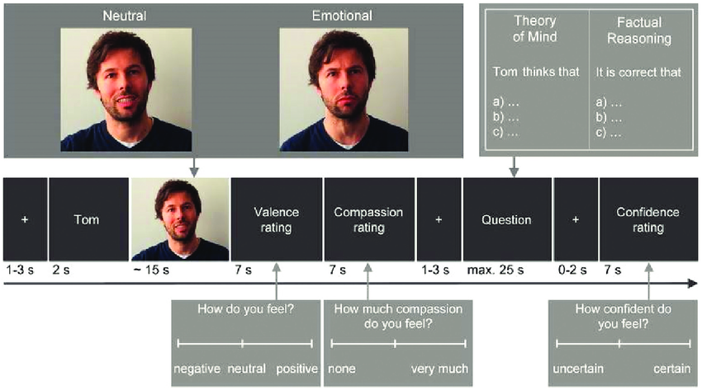

**Prosocial Learning Task: Lockwooed Et Al 2016**

